Wordpress | Exercise No.4 | Batch-07

PROBLEM STATEMENT
- INSTALL A NEW TEXT EDITOR “TINYMCE ADVANCED”
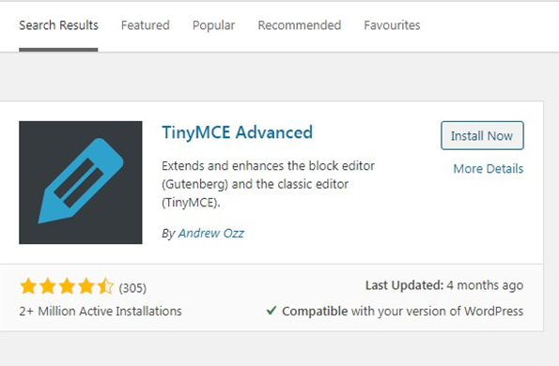

- WRITE 2 ARTICLES/BLOGS ALONG WITH CATEGORIES
ARTICLE 1
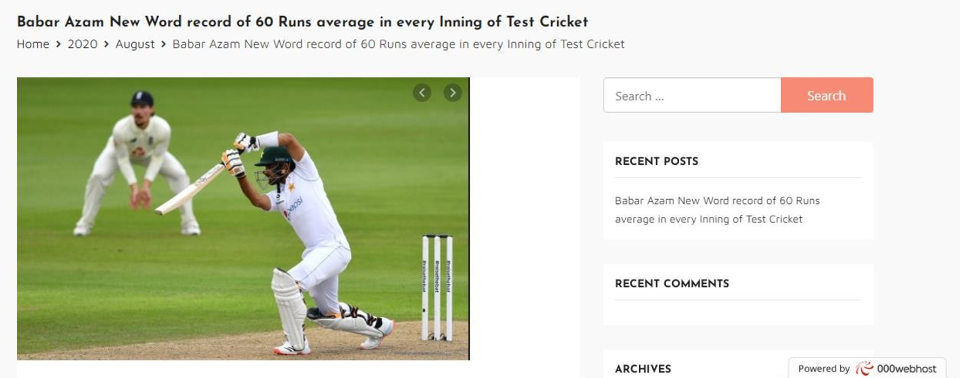
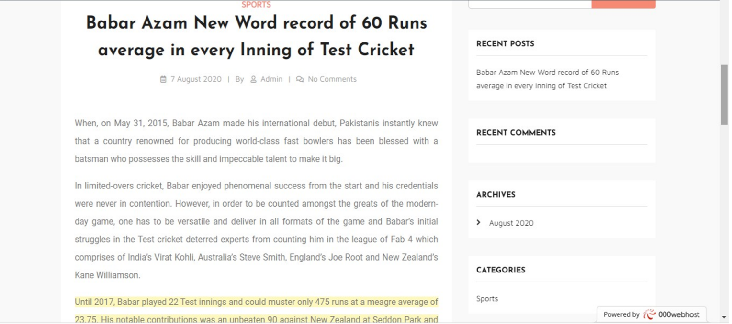
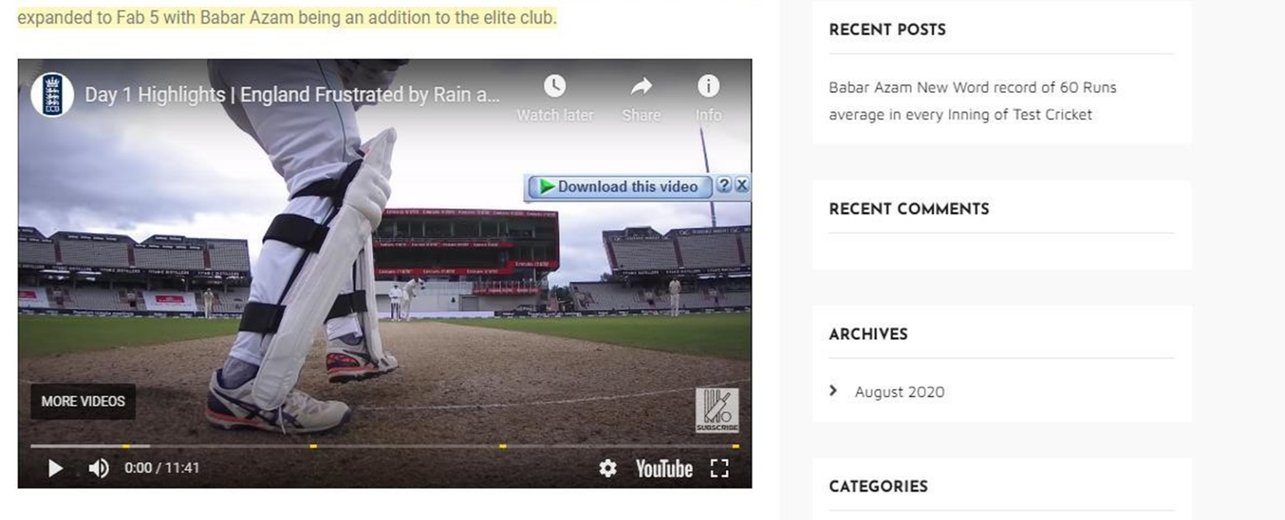

ARTICLE 2
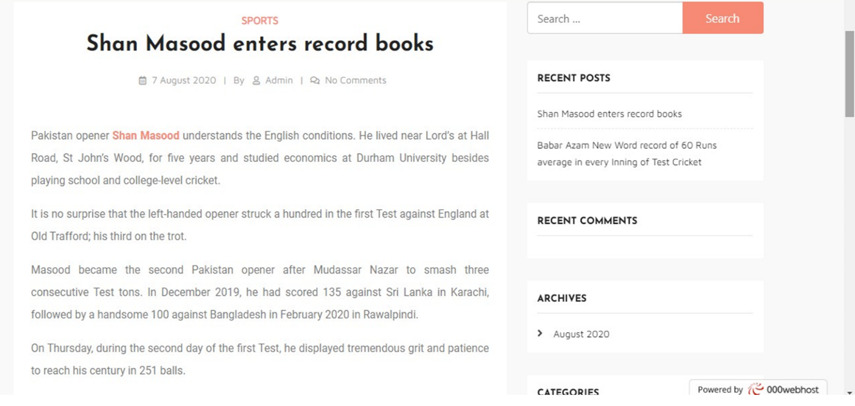

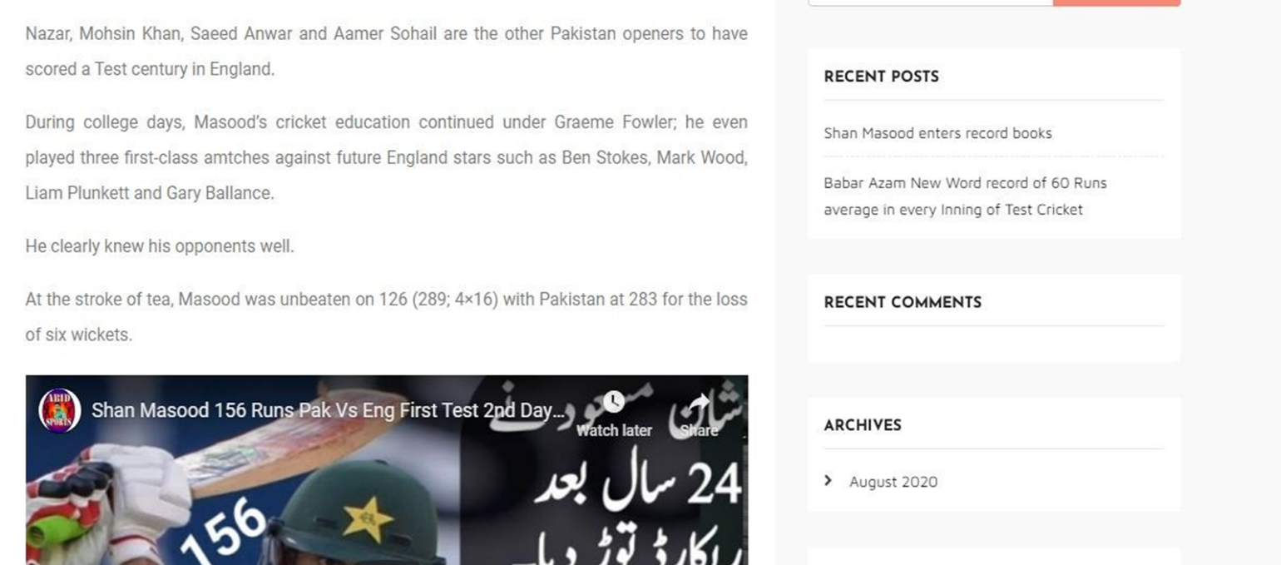

- AND FINALLY PUBLISH THEM AND SHOW THE CATEGORIES IN MENU

