Hands-on Exercise No. 4 Batch-07
Freelancing

Task 1:
Visit any traditional freelance platform. Search and pick a job post relevant to your skillset/niche.
PCB Designing
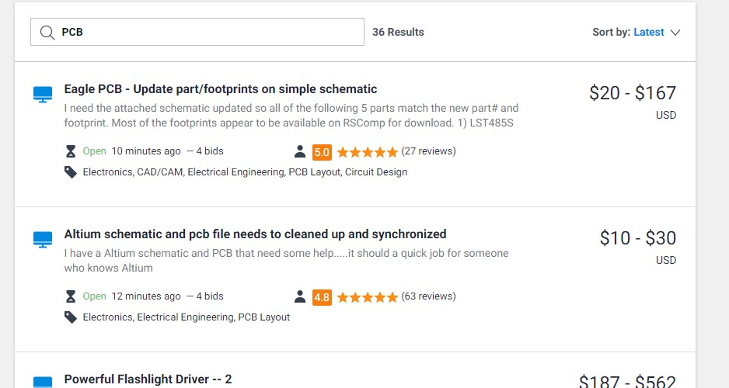

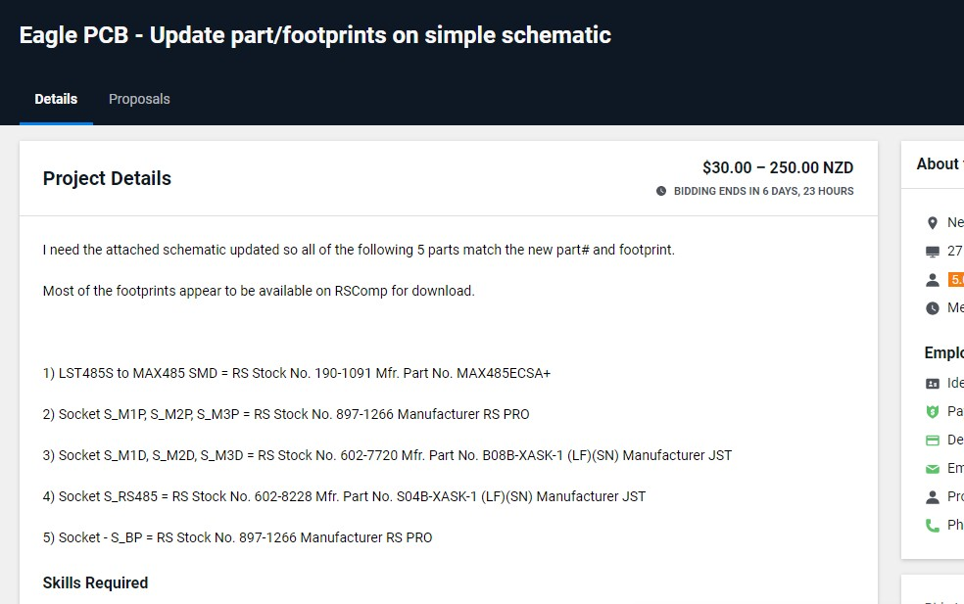

Task 2:
Read the job post carefully and write an appropriate cover letter/proposal for the job post by considering 7 effective bidding points taught in Lesson 97-108.

Proposal:
I'm a professional PCB Designer with 4 years of experience in various designs. I have experience with Arduino, microcontrollers and can Create a PCB to your
specifications up to 60 components. I can help you with complete product development from scratch of the circuit and till its PCB designing and Gerber files for the Manufacturer.

My Expertise:

Software Tools
- Altium
- Proteus

Circuit Designing Services
- AC to DC Power Supplies
- DC to DC Power Supplies
- Buck-Boost converters
- LED Drivers
- Audio Amplifiers
- Battery Charger
- Sensor Solutions

Available Services
- Circuit Development
- PCB Designing & debugging
- Circuit Troubleshooting
- Circuit Assistance

I'll provide you all related files
- Schematic file
- Layout file
- Gerber file
- Bill of Materials (BOM)
- PDFs

Final deliverable Files
- Schematic Design
- PCB Design
- Gerber Files (for PCB Manufacturing)
- BOM (for PCB Assembling)
You can contact me if you have any questions about your PCB and circuit. Furthermore, I will provide complete support throughout your PCB development

Regards

XYZ

Task 3:
Why do you think you are a good fit for this particular project?
Answer: Yes Of course I am 100% fit and eligible for this project as I have completed many project related to this work. I have completed 22 projects on Fiverr.
Do you have suggestions to make this project run successfully (share strategy)?
  - You should have complete detail and information about the project.
  - Understand the requirements of client
  - SET delivery time accordingly if you are sure you can deliver in this duration
  - Constantly asked the any required information from client
  - Give Him progress report

