
WORDPRESS

DIGISKILLS

DigiSkills Batch-07

EXERCISE

MITT GOVERNMENT OF PAKISTAN

No.03

Username: Maliksaleem1993@gmail.com

2020

ASSIGNMENT

MUHAMMAD SALEEM

- Problem Statement

Create a new website by installing WordPress on Localhost/web hosting. Install the "Elementor" plugin to the website. Design a new Page by using the Elementor plugin.
Add an image and a video on the page by using the Elementor (Provide screenshots of plugin installation and final page design).

- INSTALLED ELEMENTOR:

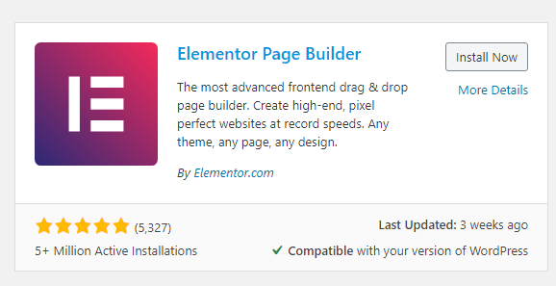

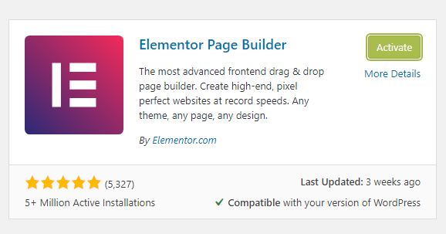
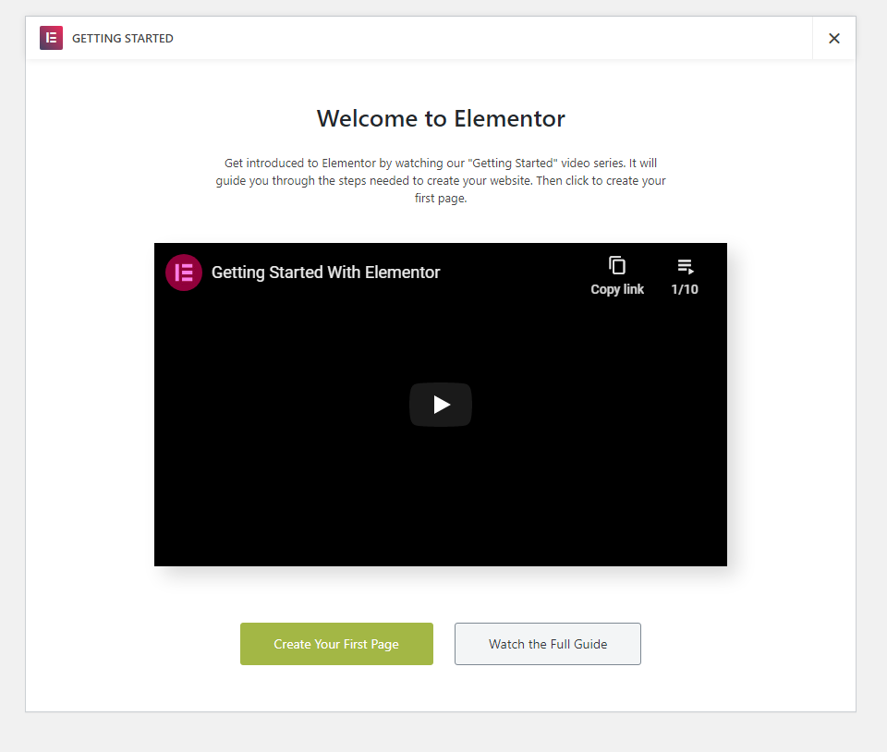
- BUILDING A PAGE USING ELEMENTOR
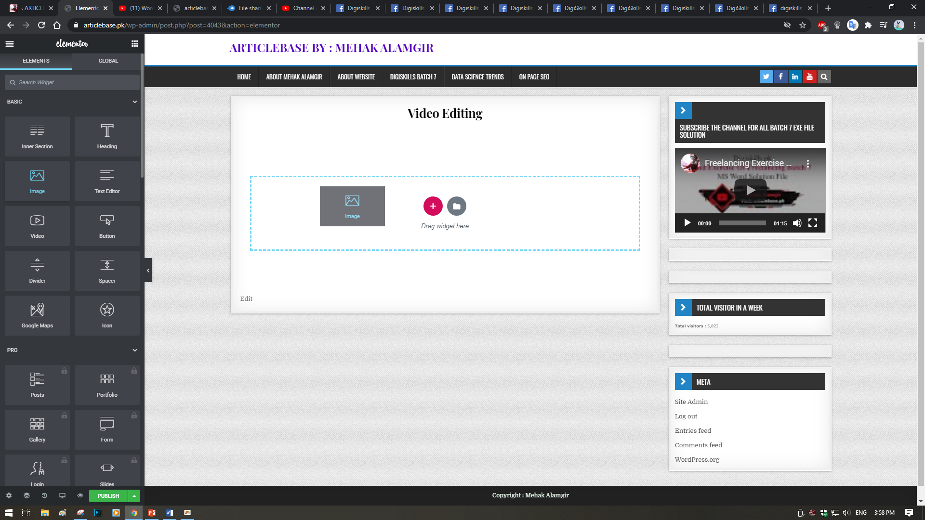

- ADD PICTURE USING ELEMENTOR
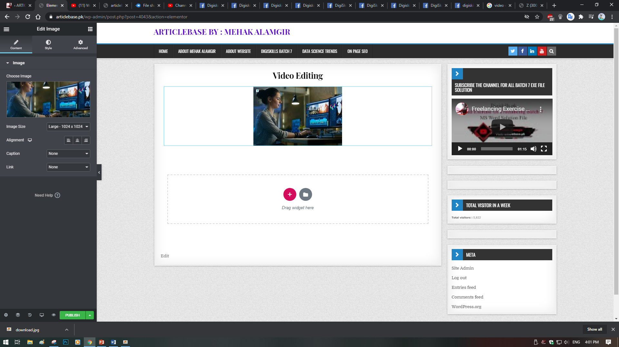

- ADD VIDEO USING ELEMENTOR

