FREELANCING EXERCISE 3 DIGISKILLS BATCH 7
Task 1: Register yourself
I have register my self on a freelancing platform.
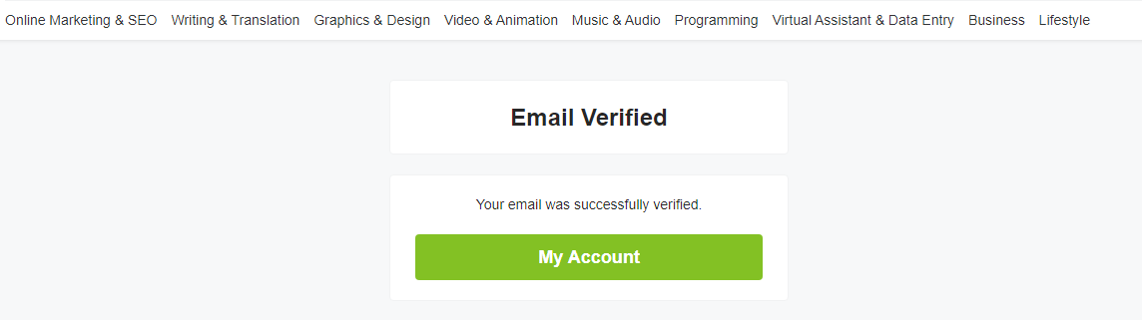

Task 2: My portfolio as a graphic designer
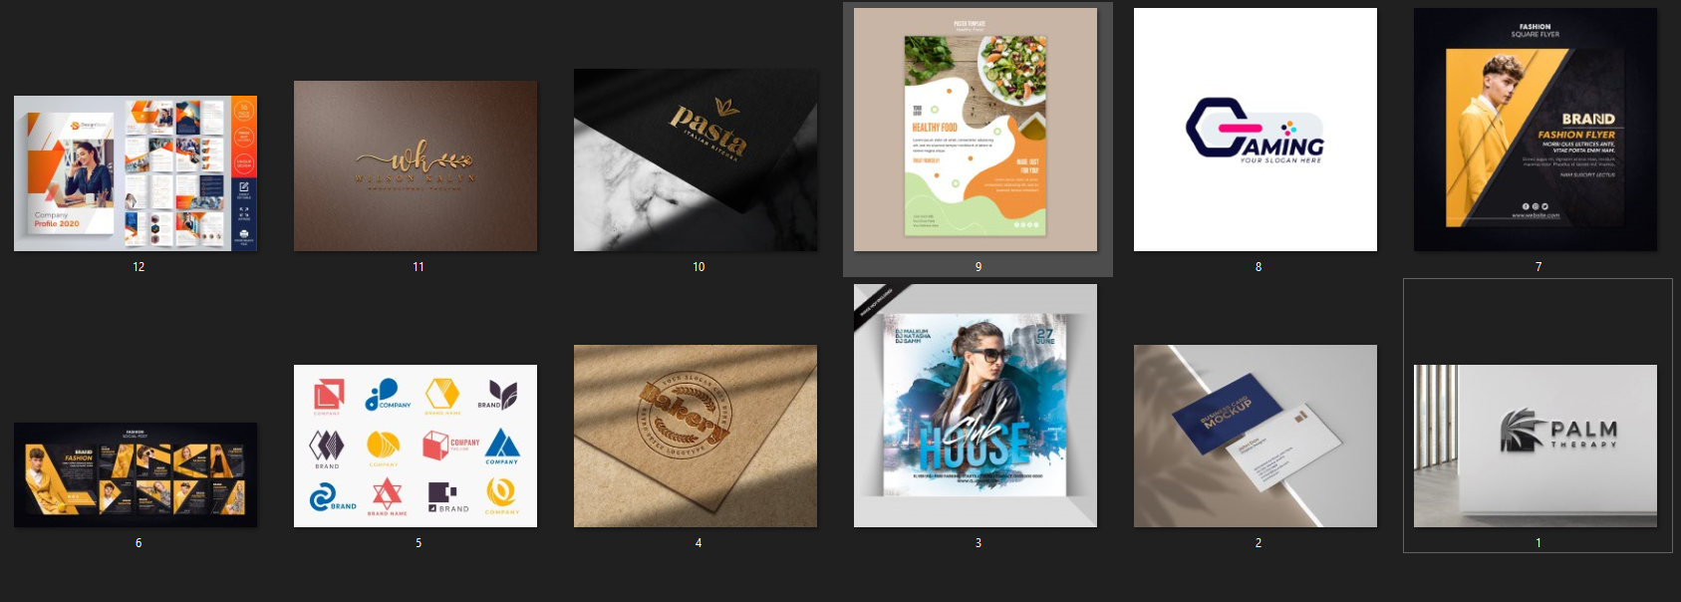

Task 3: Write a brief description of your previous work. You can explain the tools and techniques you had used to complete the previous job
I am a graphic designer and working on different freelancing platform. I have complete 4 project as a graphics designer on Upwork, fiverr, freelance and at truelancer. I have a vast experience in designing business cards, flyers and logos. Software I used for graphic designing include Adobe's Creative Suite both adobe photoshop and adobe illustrator
AVAILABLE SERVICES:
- Logo Design
- Poster Design
- Banner Design
- Stationery Design
- Email Newsletter Design
- Business Logo Design
- Corporate / Brand Identity Solution
- Corporate Identity Kit
- Design Business Stationery Design
- Corporate / Business Profile
- Design Brochures & Flyers Design Magazine
- Ads & Poster Design
- Outdoor Banners / Flex Design
- Catalogs & Booklets Design
- Invitation & Greeting Cards Design

WITH THIS SELECT HOURLY YOU WILL GET:

- 3 Beginning plan ideas (twofold sided)
- Vector quality designs made utilizing the most recent exceptional programming
- Print prepared cards provided in a PDF group with important harvest marks.
- Boundless modifications until you\'re Fulfilled!

WHAT YOU GET WITH THIS OFFER
- √ A1/A2/A3/A4/A5/A6
- √ Print Ready 300 dpi image in any format with bleed
- √ Unlimited amendments until your totally happy
- √ Fast turnaround without losing quality
- √ 100% Feedback record
- √ 100% Original artwork
- √ 100% FREE advice
- √ No hidden charges for speedy turnover

Sample work is attached below

Task 4 : Now upload file on freelancing site as a portfolio

Uploading portfolio

