

MUHAMMAD SALEEM

Due Date: 23 July 2020
BATCH⁰⁷
2020

Username:
Maliksaleem1993@gmail.com

DIGITAL

MARKETING

ASSIGNMENT^{No.3}

DigiSkills
- Scenario:

Modwear, a newly launched brand is looking for a Digital Marketer for their Manchester (UK) outlet who can create a result-oriented advertisement campaign for Mod clothing. The goal of this brand is to boost website sales using Google ads with automated ads that show on Google, Google Maps, and across the web. The company wants to run this ad for 30 days with a daily budget of £25 (PKR 5000).

- Tasks 01:

CREATE A NEW CAMPAIGN IN GOOGLE ADS (ADWORDS) WITH A CAMPAIGN GOAL AS "SALES" AND CAMPAIGN TYPE AS "SMART".

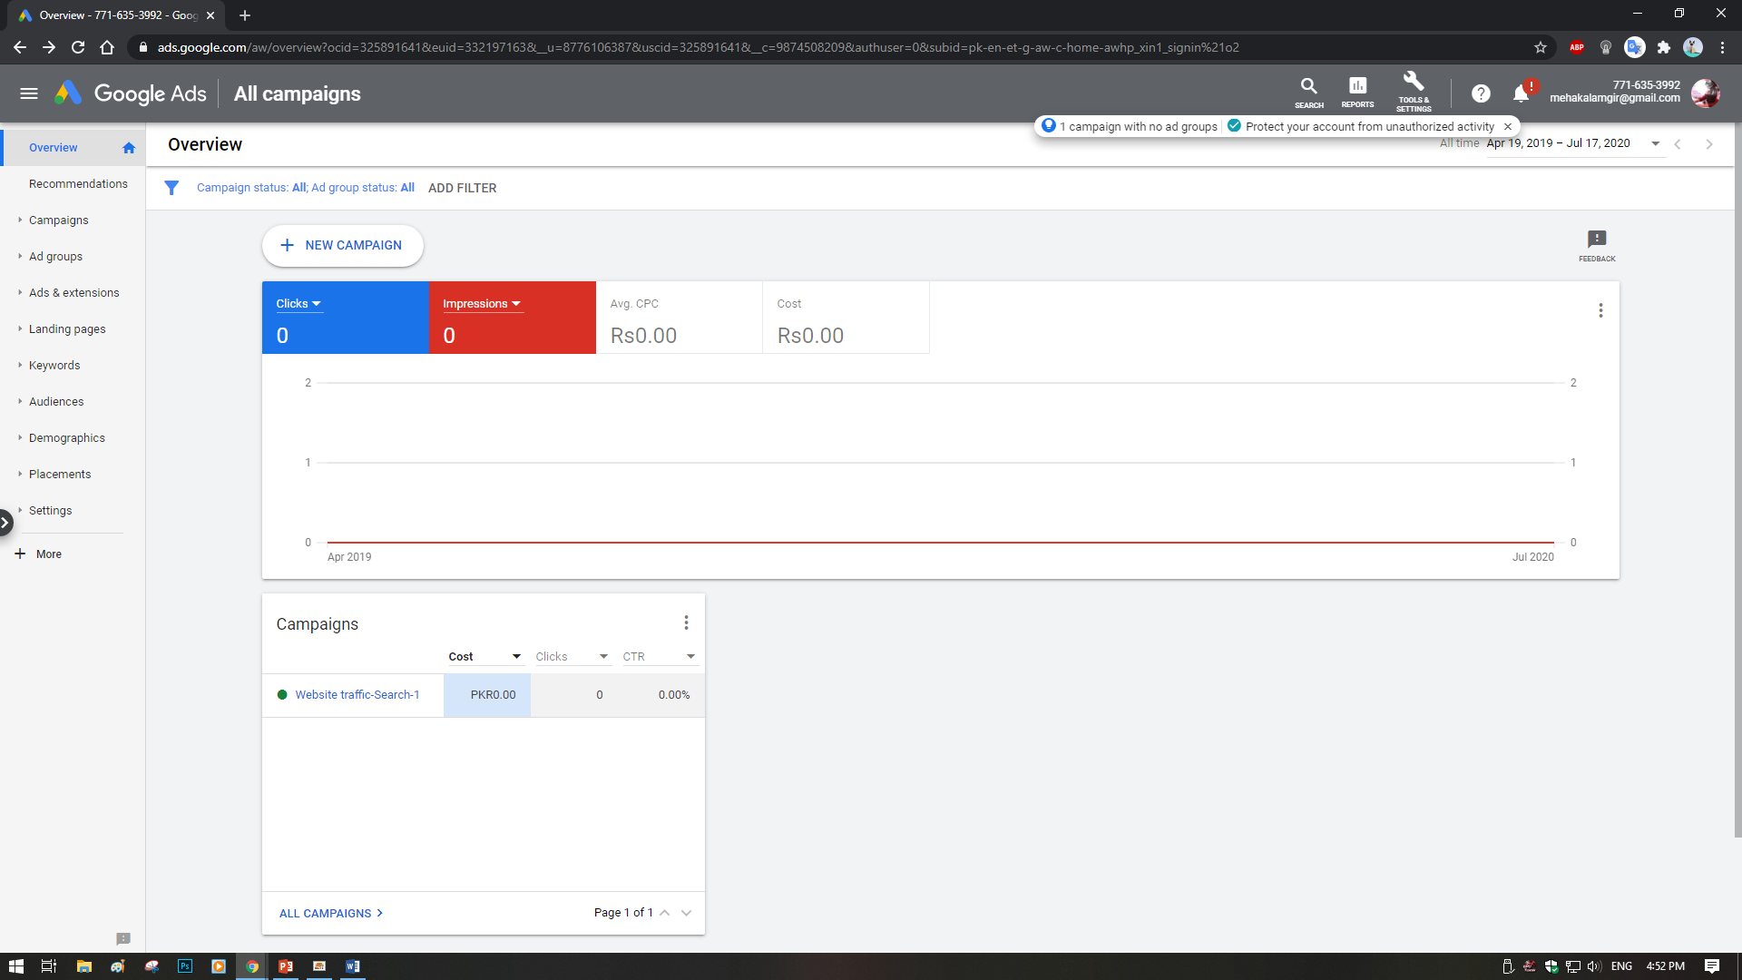
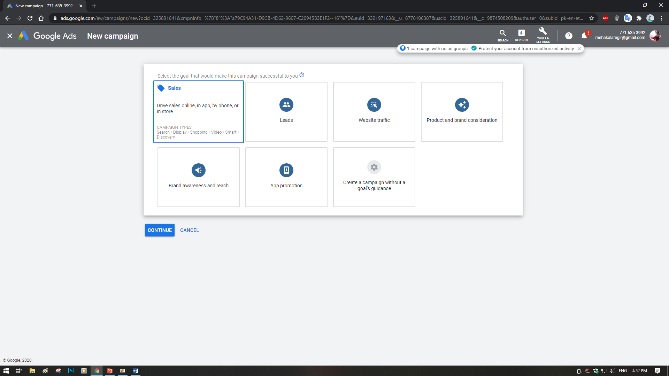
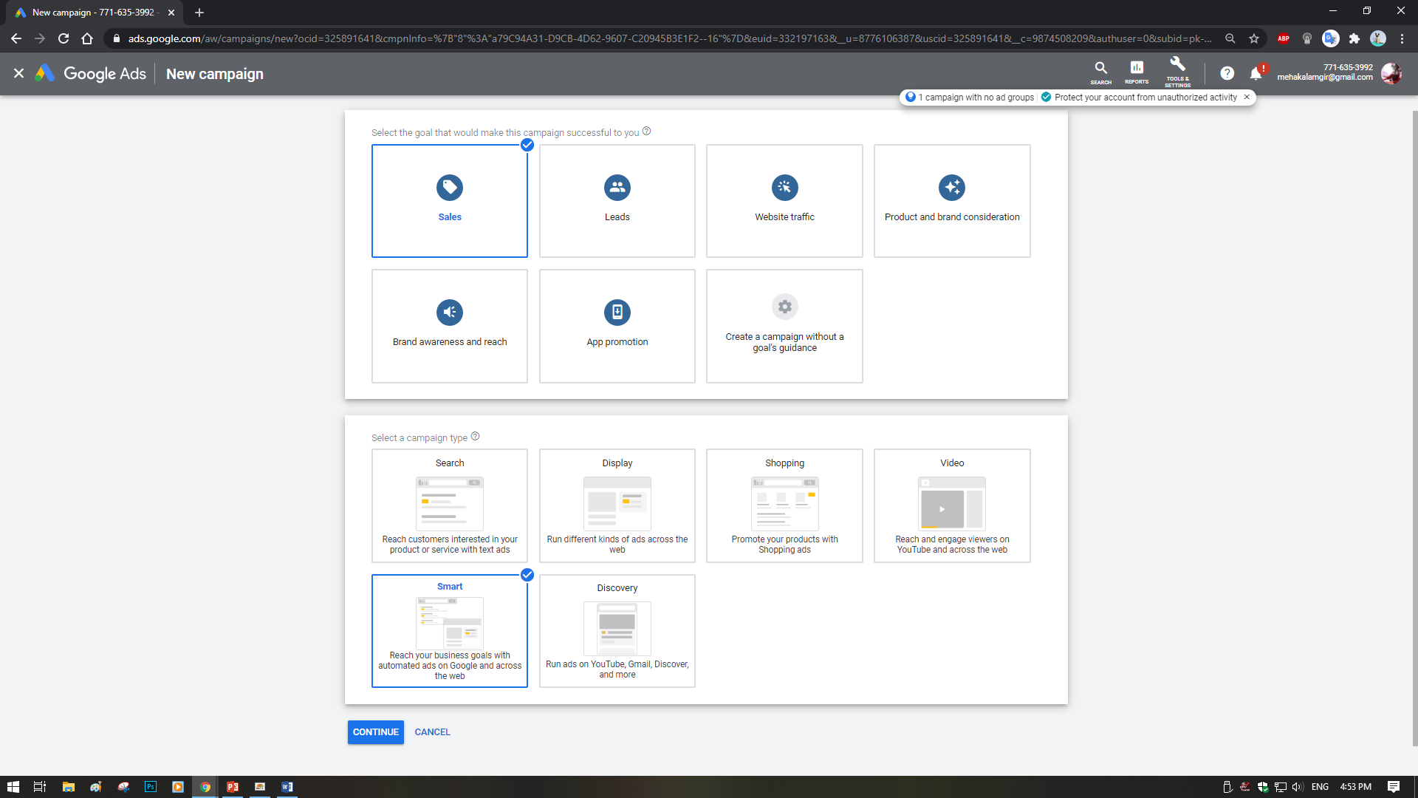

- Tasks 02:

DESCRIBE YOUR BUSINESS AS PER THE SCENARIO.

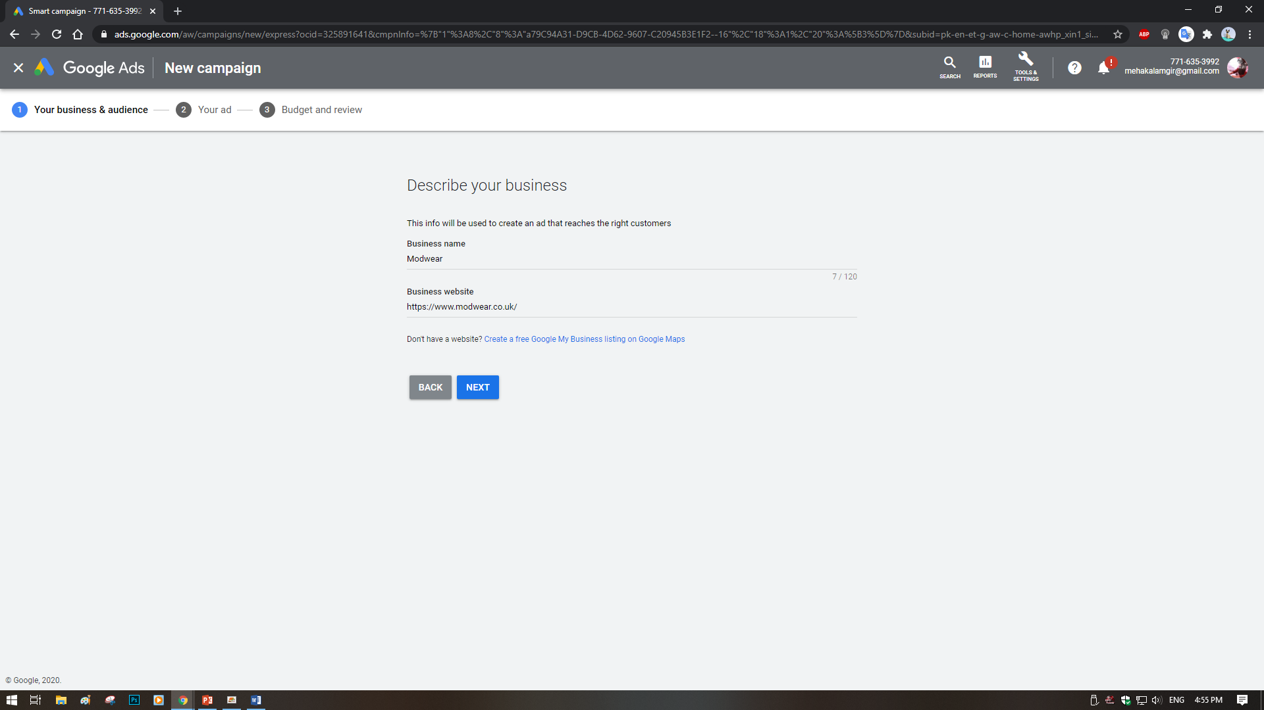
- Tasks 03:

SET THE LOCATION FOR THE AD AS PER THE SCENARIO.

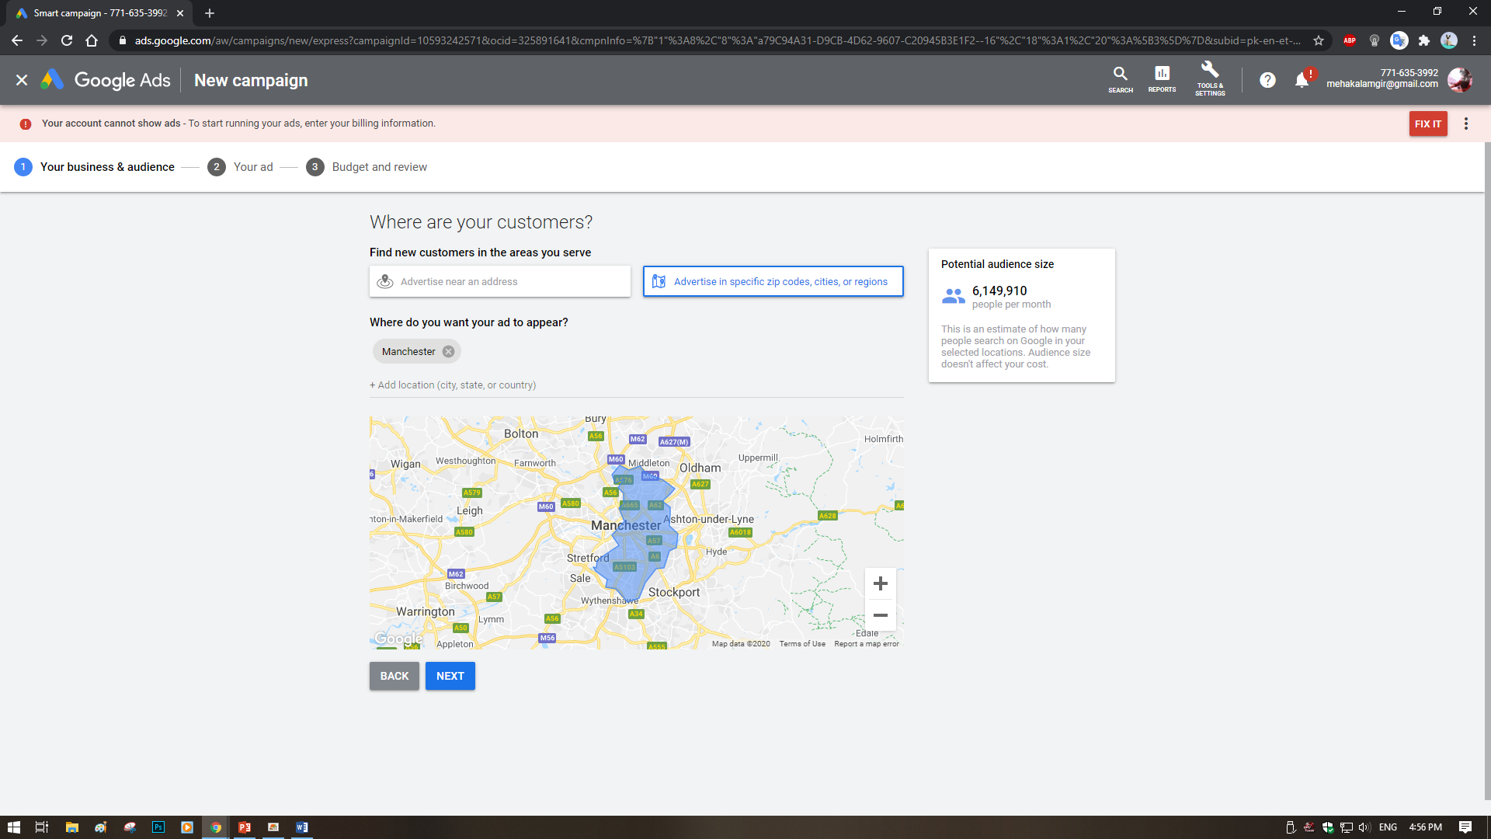

- Tasks 04:

ADD BUSINESS CATEGORY AND PRODUCTS BASED ON THE SCENARIO.

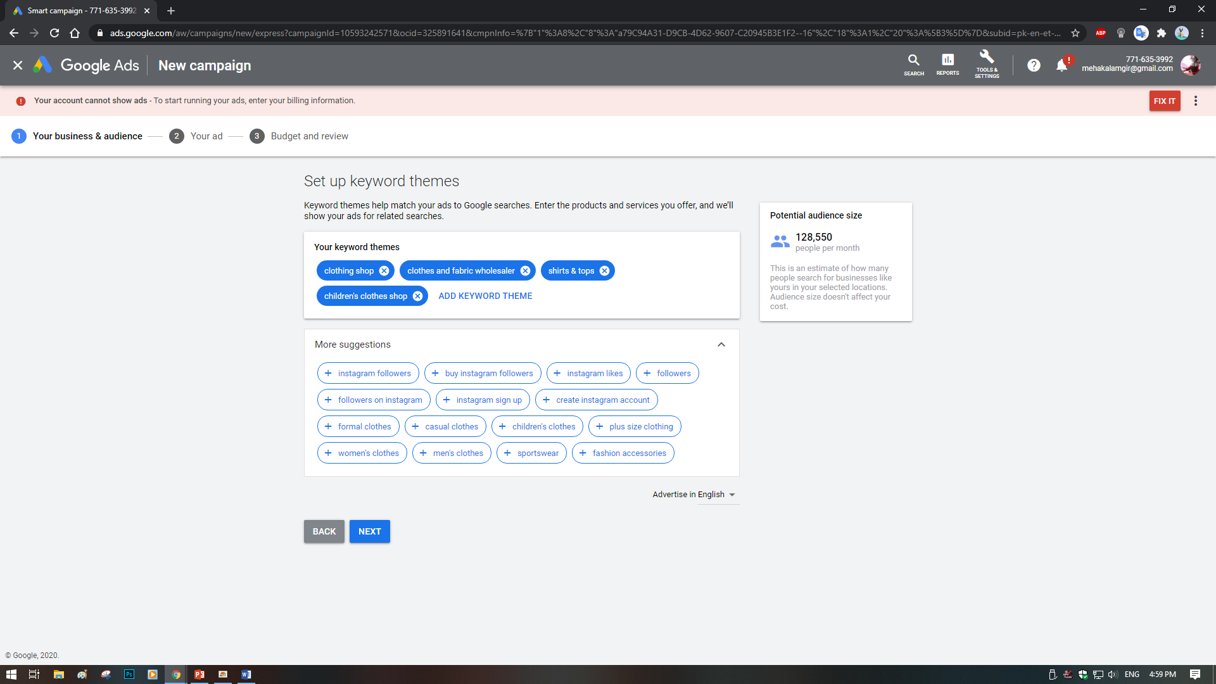
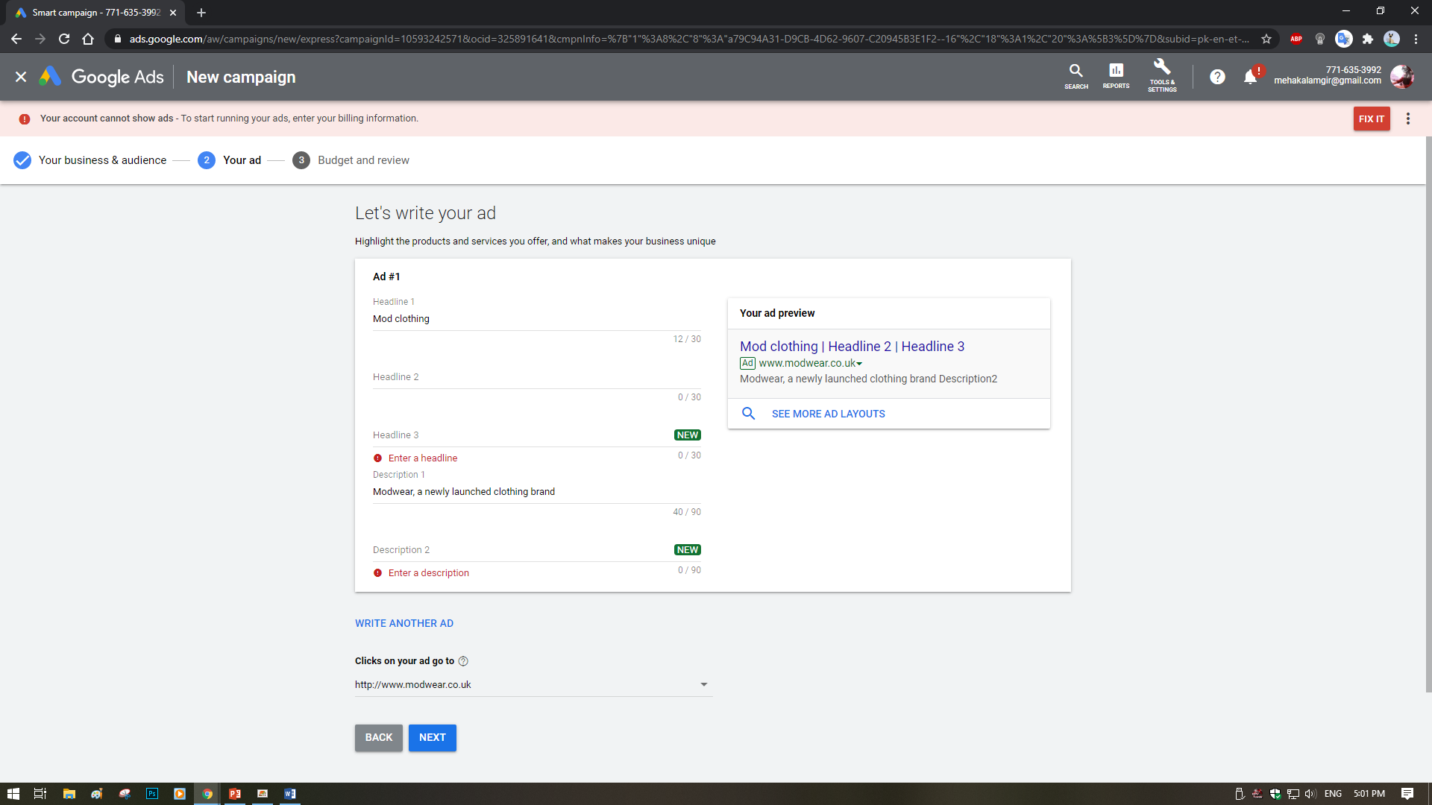

- Tasks 05:

WRITE CONTENT OF THE AD AND SET THE DAILY BUDGET AS PER THE SCENARIO

